WWD 130
Site Plan

- Wireframe
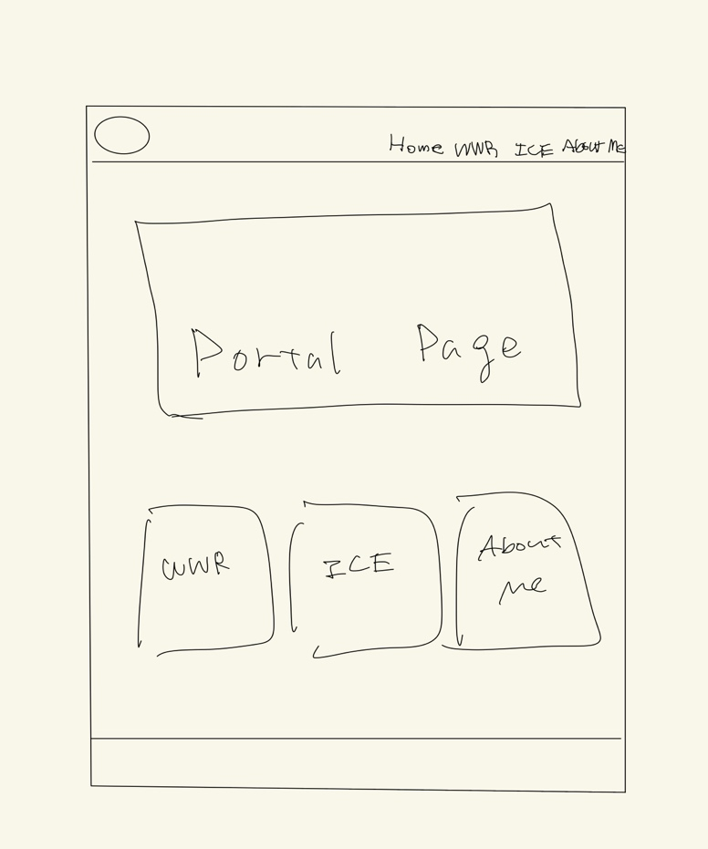

- Logo
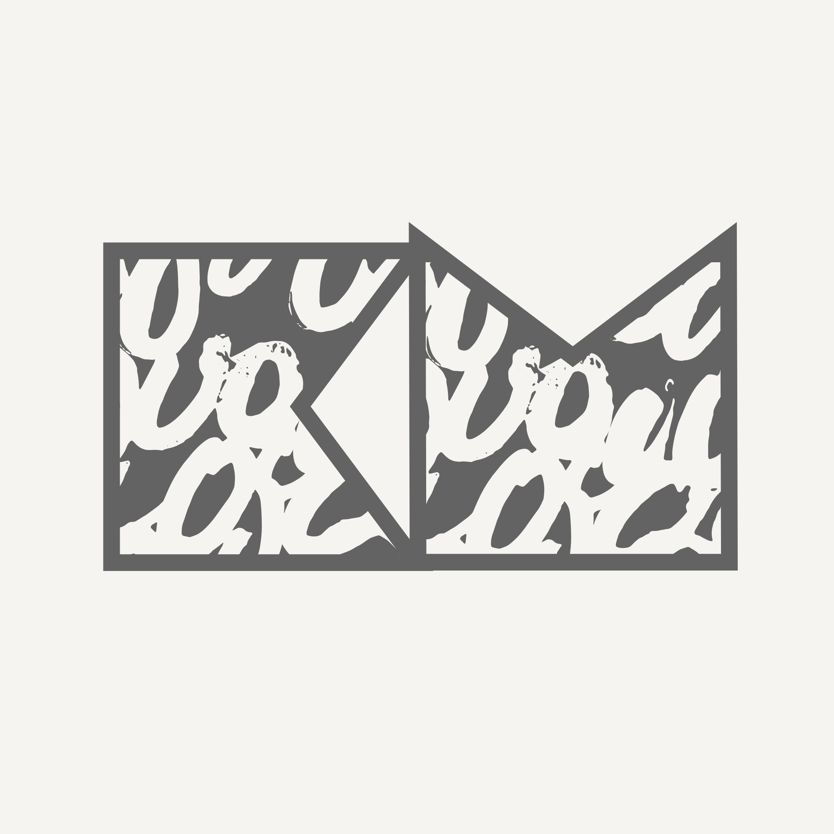

- Color
#636363, #6E9FDB, #F7F0F0, #16425B, #F05D5E
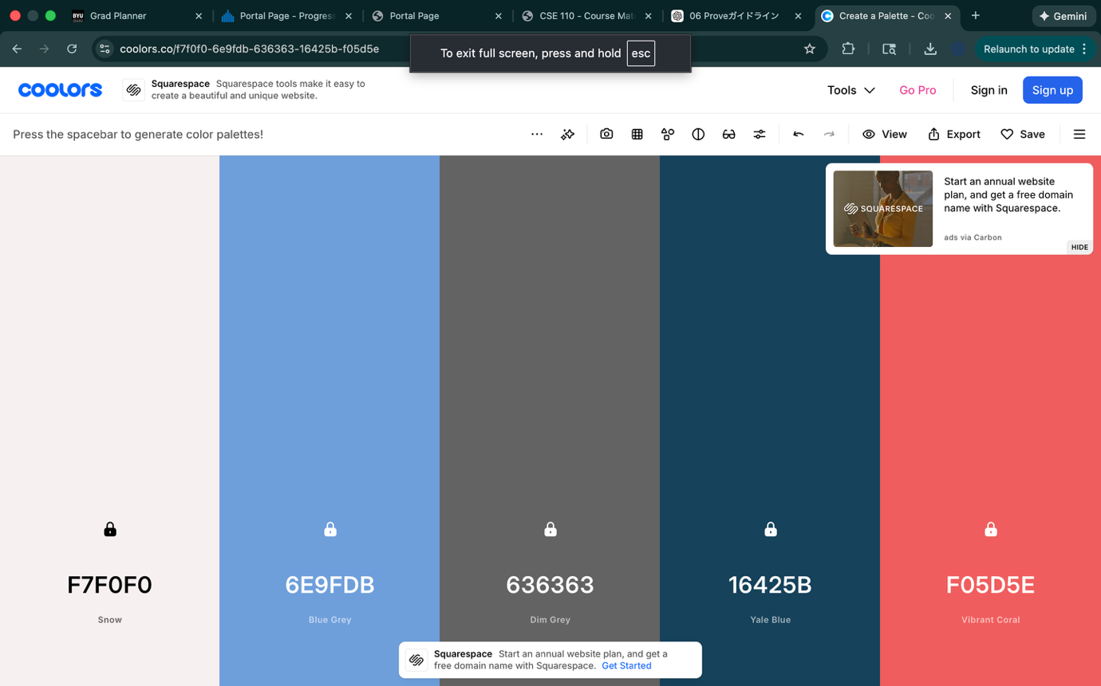

- Fonts
Headings – Plaster, League Spartan, Tektur
Paragraphs – Inter, Roboto, Open Sans
Nav - Hubot Sans, Coda, Lexend Deca

